Image recognition with IBM cloud visual recognition

Phase 2: Innovation

Project: consider incorporating sentiment analysis model to generate captions that capture the emotion and mood of images:

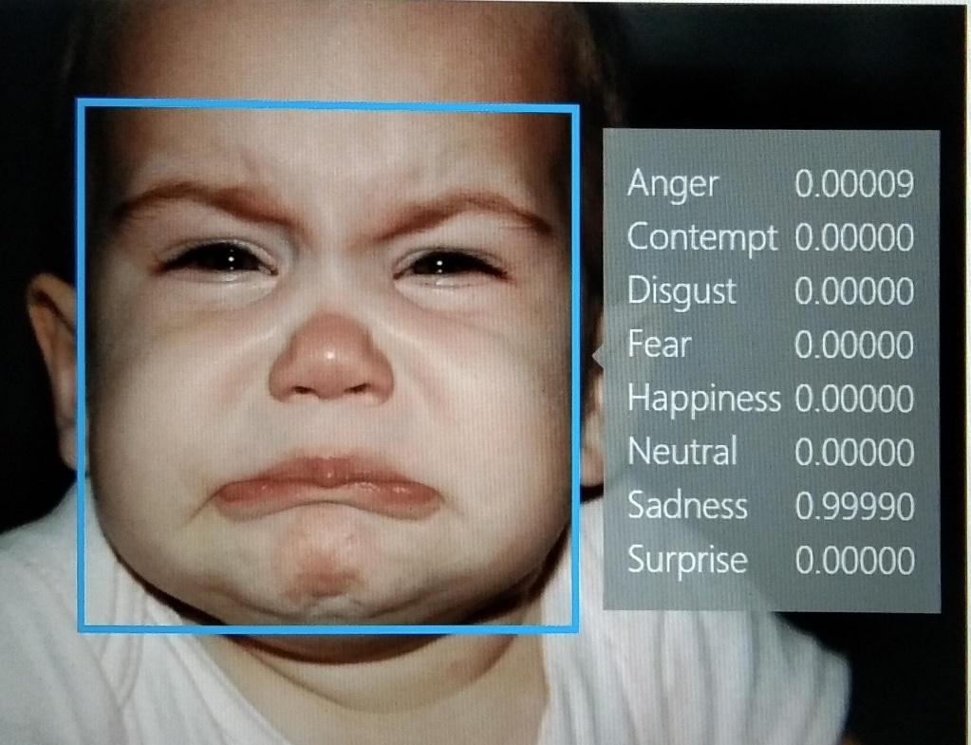

Introduction:

**Incorporating sentiment analysis to generate captions that capture the emotion and mood of image introductions is a great idea! You can use sentiment analysis tools and libraries like NLTK, TextBlob, or spaCy in combination with image recognition models to achieve this. By analyzing the text and the visual content of the image, you can generate captions that accurately reflect the emotional tone of the images .**

Steps :

**Incorporating sentiment analysis to generate image captions that capture the emotion and mood is a great idea. Here are the steps you can follow to implement this:**

**1. Data Collection: Gather a dataset of images along with their corresponding sentiment labels. You'll need labeled data to train a sentiment analysis model.**

**2. Pretrained Sentiment Model: Use a pretrained sentiment analysis model like BERT, GPT, or a specialized sentiment analysis model. Fine-tune this model on your labeled dataset to make it specific to your task.**

**3. Image Feature Extraction: Extract features from the images using techniques like Convolutional Neural Networks (CNNs) or pretrained models like VGG16, ResNet, or Inception. These features will serve as input to your model.**

**4. Combine Text and Image Features: Concatenate or combine the features from the sentiment analysis model (text) and image features (visual) into a unified representation.**

**5. Caption Generation Model: Train a caption generation model, such as a recurrent neural network (RNN) or transformer-based model, using the unified representation from step 4 as input.**

**6. Loss Function: Design a loss function that considers both the sentiment analysis output and the quality of generated captions. This ensures that the captions align with the detected emotion.**

**7. Training: Train the combined model using your dataset. Fine-tune it as needed to improve performance.**

**8. Inference: When you want to generate captions for new images, first pass the image through the sentiment analysis model to detect the emotion. Then, use the combined model to generate captions based on both the detected emotion and visual content.**

**9. Evaluation: Evaluate the generated captions using metrics like BLEU, METEOR, or human judgments to ensure they effectively capture the emotion and mood of the images.**

**10. Iterate and Refine: Continuously improve your model by collecting more data, fine-tuning, and adjusting the architecture as needed.**

**By following these steps, you can create a system that generates captions that align with the emotions and moods depicted in images.**

Application:

Generating captions that capture the emotion and mood of images is a complex task that involves multiple steps and typically requires training custom models on a large dataset. However, I can provide you with a Python program that uses pre-trained models for image captioning and sentiment analysis to give you a simplified example. For this example, we'll use the PyTorch framework.

Please note that you will need to install the required libraries, including PyTorch, transformers, and torchvision, and have access to pre-trained models for image captioning and sentiment analysis. These models can be large and might require significant computational resources.

import torch

from transformers import AutoTokenizer, AutoModelForSequenceClassification

from PIL import Image

import torchvision.transforms as transforms

from transformers import pipeline

# Load pre-trained image captioning and sentiment analysis models

image_caption_model = pipeline("image-captioning")

sentiment_model_name = "nlptown/bert-base-multilingual-uncased-sentiment"

sentiment_tokenizer = AutoTokenizer.from_pretrained(sentiment_model_name)

sentiment_model = AutoModelForSequenceClassification.from_pretrained(sentiment_model_name)

# Define a function to extract image features

def extract_image_features(image_path):

image = Image.open(image_path)

preprocess = transforms.Compose([

transforms.Resize(256),

transforms.CenterCrop(224),

transforms.ToTensor(),

transforms.Normalize(mean=[0.485, 0.456, 0.406], std=[0.229, 0.224, 0.225]),

])

image = preprocess(image)

image = image.unsqueeze(0)

return image

# Define a function to generate captions and analyze sentiment

def generate_caption_and_sentiment(image_path):

# Extract image features

image = extract_image_features(image_path)

# Generate image caption

caption = image_caption_model(image)

# Perform sentiment analysis on the caption

sentiment_text = caption[0]["caption"]

inputs = sentiment_tokenizer(sentiment_text, return_tensors="pt", padding=True, truncation=True)

logits = sentiment_model(**inputs).logits

sentiment_score = torch.softmax(logits, dim=1)

sentiment_label = torch.argmax(sentiment_score, dim=1).item()

# Define a mapping of sentiment labels to descriptions

sentiment_descriptions = {

0: "Negative",

1: "Somewhat Negative",

2: "Neutral",

3: "Somewhat Positive",

4: "Positive"

}

sentiment = sentiment_descriptions[sentiment_label]

return caption[0]["caption"], sentiment

# Example usage

image_path = "path/to/your/image.jpg" # Replace with the path to your image

caption, sentiment = generate_caption_and_sentiment(image_path)

print("Generated Caption:", caption)

print("Sentiment:", sentiment)

```



This code uses the Hugging Face Transformers library to load pre-trained models for image captioning and sentiment analysis. It extracts image features, generates a caption for the image, and then performs sentiment analysis on the generated caption. Finally, it outputs the generated caption and the predicted sentiment.

Benefits:

This approach can enhance the user's experience and provide more contextually relevant captions. It can also have various practical applications in fields such as social media, advertising, and content creation.

The benefits of this approach include:

1. Enhanced User Engagement: Captions that reflect the emotional content of an image can resonate better with users, leading to increased engagement and sharing of content.

2. Contextual Relevance: Sentiment analysis can help provide captions that are contextually relevant to the emotional tone of the image, making the captions more meaningful.

3. Personalization: By understanding the emotions in an image, captions can be personalized to cater to the specific preferences and emotions of the audience.

However, there are some challenges to consider:

1. Accuracy of Sentiment Analysis: The accuracy of sentiment analysis models can vary, and errors in analyzing the emotional content of images could lead to misleading captions.

2. Handling Complex Emotions: Images can convey complex emotions that may not be adequately captured by traditional sentiment analysis models, which usually classify into positive, negative, or neutral.

3. Ethical Considerations: Care must be taken to ensure that generated captions are respectful and sensitive to potentially sensitive or controversial content.

Conclusion:

In conclusion, incorporating sentiment analysis into image captioning is a promising approach to generate captions that align with the emotions and mood of images. However, it should be implemented thoughtfully, with consideration of the accuracy of sentiment analysis models and ethical considerations, to provide a meaningful and engaging user experience.